Practical - 7

Practical Title: PHP Form Processing with Server-Side Validation and CSV/JSON File StorageProblem Definition: Display event lists, student profiles, notices, or FAQs from external JSON files using Fetch API. Implement dynamic rendering, search, filter, sorting, and pagination.

Theory :

Is the form submitted using POST?
Ans:Yes, the form uses the POST method to submit data securely.

Are inputs validated and sanitized server side?
Ans: Yes, inputs are validated and sanitized on the server side.

Is file writing handled safely?
Ans: Yes, file writing is performed safely with proper handling.

Are success and error responses displayed clearly?

Ans:Yes, clear success and error messages are displayed to the user.

Data:

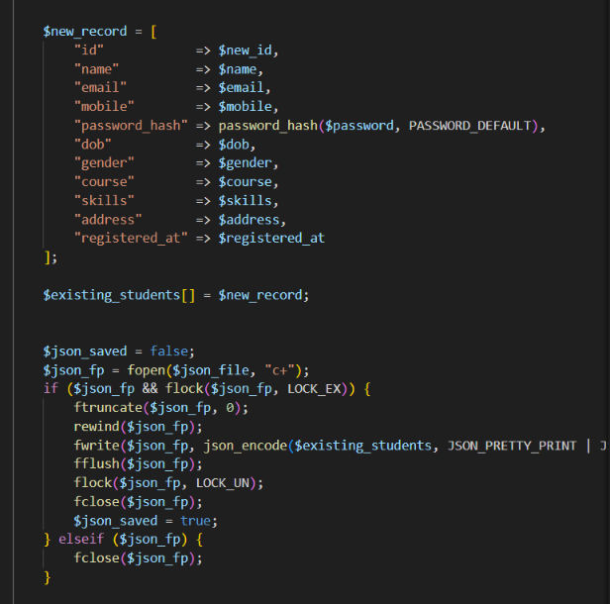

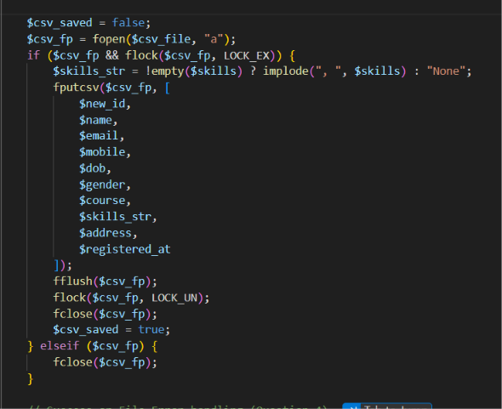
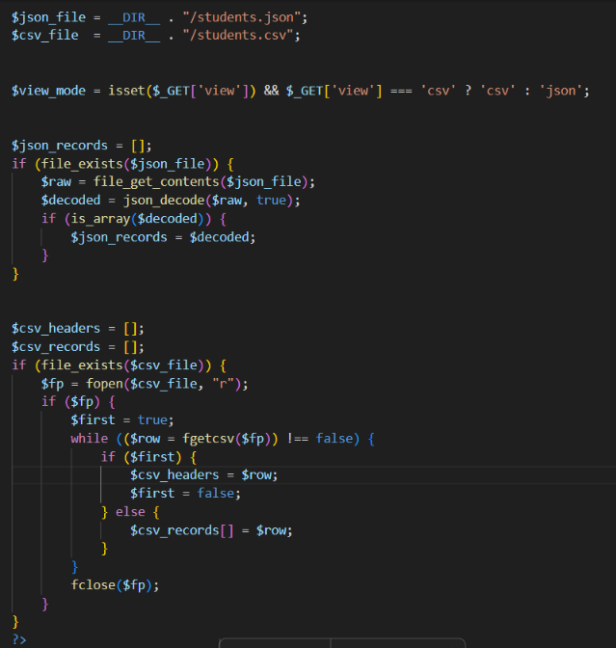

Implementation/ Output/Result

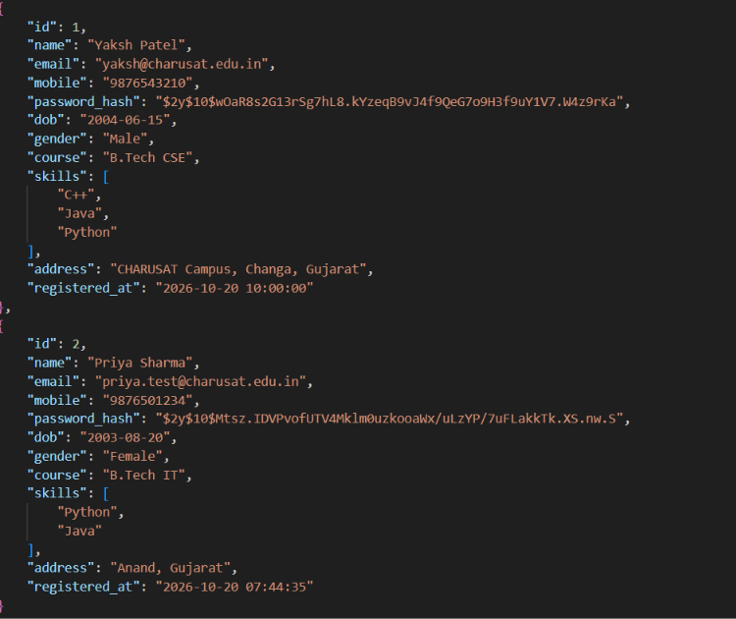

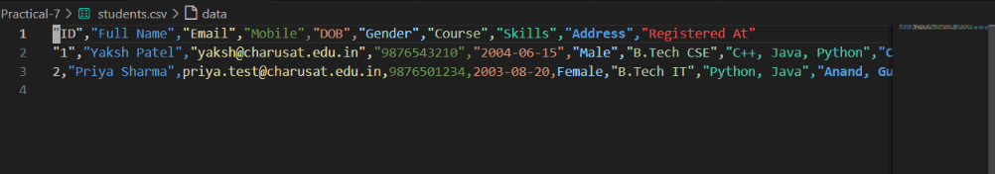
GitHub Repository Link:
https://github.com/yakshu205/StudentHub/tree/main/Practical-7

Learning Outcomes:

->Students will understand how to process form data using PHP POST requests.

->Students will implement server-side validation and input sanitization.

->Students will learn safe file handling and storage using CSV/JSON formats.

->Students will display clear success and error messages based on processing results.

->Students will develop a secure and reliable backend form-processing system.

Faculty Remarks: (Keep this blank for faculty)

